International Journal of Intelligent Knowledge Processing Systems
Vol., No., Month, Year, pp. **-**

Journal homepage: https://ijikps.org/

INSTRUCTIONS FOR PREPARING PAPERS FOR INTERNATIONAL JOURNAL OF INTELLIGENT KNOWLEDGE PROCESSING SYSTEMS
Aaa Surname^{1*}, Bbb B. Surname², Ccc C.C. Surname³

¹ Affiliation, address
² Affiliation, address
³ Affiliation, address

Corresponding Author Email:
ABSTRACT

Abstract is the core of the manuscript. It should contain the research background, objective, method and results achieved and to the point not exceeding 300 words. Authors are advised not to include any citations in this section. The abstract section is mandatory, with a word limit of 200 words. The purpose, methodology, results & conclusions, and implications should be summarized here. Avoid inserting any reference in this section. In the Keywords section, please enter words or phrases in alphabetical order. There is a maximum of 8 keywords.

Keywords: key word 1, key word 2, key word 3, key word 4, key word 5, key word 6, key word 7, key word 8
(no more than 8 keywords)

Introduction

This template, modified in MS Word 2007 and saved as a “Word 97-2003 Document” for the PC, provides authors with most of the formatting specifications needed for preparing electronic versions of their papers. All standard paper components have been specified for three reasons: (1) ease of use when formatting individual papers, (2) automatic compliance to electronic requirements that facilitate the concurrent or later production of electronic products, and (3) conformity of style throughout a conference proceedings. Margins, column widths, line spacing, and type styles are built-in; examples of the type styles are provided throughout this document and are identified in italic type, within parentheses, following the example. Some components, such as multi-leveled equations, graphics, and tables are not prescribed, although the various table text styles are provided. The formatter will need to create these components, incorporating the applicable criteria that follow.

- PAGE SETUP

The book size should be in A4 (8.27 inches × 11.69 inches). Do not change the current page settings when you use the template.
The number of pages for the manuscript must be no more than ten, including all the sections. Please make sure that the whole text ends on an even page. Please do not insert page numbers. Please do not use the Headers or the Footers because they are reserved for the technical editing by editors.

- SECTION HEADINGS

The way that section titles and other headings are displayed in these instructions, is meant to be followed in your paper.
Level 1: Times New Roman, 10, bold, all letters capitalized, 20 pts spacing above heading and 10 pts below, Example: “3. SECTION HEADINGS”
Level 2: Times New Roman, 10, bold, only the first letter as well as proper nouns capitalized, 10 pts spacing above heading, 10 pts spacing below heading. However, when a Level 2 heading is directly above a Level 1 spacing, just leave 10 pts spacing between them instead of 20 pts. Example: “4.1 Paper title”.
Level 3: Times New Roman, 10, not bold, only the first letter as well as proper nouns capitalized, 10 pts spacing above and below heading. However, when a Level 3 heading is directly below a Level 2 heading, just leave 10 pts spacing between them instead of 20 pts. Example: “4.2.1 Name”

More details about Paper title and Author information

4.1 Paper title

Paper titles should be written in upper-case and lower-case letters, not all upper-case, e.g., “Instructions for preparing papers for International Journal of Intelligent Knowledge Processing Systems”. Do not use capital letters for prepositions, articles or conjunctions unless one is the first word.
Avoid writing long formulas with subscripts in the title; short formulas that identify the elements are fine (e.g., “Nd–Fe–B”).

  - Author information

4.2.1 Name
Full names of authors are required. The middle name can be abbreviated.

4.2.2 Affiliation
Different affiliations shall be listed in separate lines. Do not insert any punctuation at the end of each affiliation. If all the authors are affiliated to the same organization, type that affiliation just once.

4.2.3 Superscripts
To match authors and their own affiliations, please insert numerical superscripts, i.e., ^{“1, 2, 3, 4 …”} followed by a space, after name and, correspondingly, before affiliation. If all the authors are affiliated to the same one organization, any number is no need.
Do not forget to denote the corresponding author with a superscript asterisk (*). You may offer emails of all co-authors. But in the final version of your manuscript, only one valid email of the corresponding author will be kept.

Math

5.1 Equations

- Tool: You are strongly recommended to use MathType (http://www.mathtype.com) to edit equations. Microsoft Equation Editor is also acceptable. (Insert | Object | Create New | Microsoft Equation or MathType Equation). “Float over text” should not be selected.
- Format: The size of equation is 10 pts. Remember to leave 10 pt spacing both above and below an equation. Set the equation flush left, without indenting it.
- Numbering: Make sure that placing and numbering of equations is consistent throughout your manuscript. References to the equations should be as Eq. (1). Make the number of an equation flush-right. For example:

(1)

  - Measurement units and numbers

Please use the SI set of units as much as possible. Wherever the application domain uses a different set of units widely, please minimize the use of non-standard units or non-standard symbols for those units. For example, the use of “a” for year (annum) is depreciated and the use of “y” is encouraged instead. Similarly, “h” should be used for hours instead of “hr” and “t” instead of “ton” or “tonne”. It is important to take care of the case in which the measurement units are typed. E.g. “Km” does not mean “kilometres”, but “Kelvin-meters”.
When providing numerical values followed by measurement units, a regular space or non-breaking space should be left between each value and its measurement unit. This rule also applies to the unit for litre, which is recommended to be capitalized as 'L'. However, no space is used for percentages and degrees Celsius (e.g., 35%, 234°C).
The authors are encouraged to render the numbers specifying the dot as a decimal separator and the comma as a thousand separator. Please use the British style for numbers – i.e. 1,000,000 and not 1000000 or 1 000 000.

TABLES AND FIGURES

6.1 General

- Briefly and descriptively title each table and caption each figure. Place figure captions below the figures whereas table titles above the tables. Please do not include captions as part of the figures or put them in “text boxes” linked to the figures. Also, do not place borders around the outside of your figures.
- All the table titles and figure captions should be centered, Times New Roman font and 10 pts in size. Just capitalize the first letter of words, phrases and sentences which are included in tables and figures.
- Reference each table and figure within the text by writing: e.g., Table 1 or Figure 1 (instead of Tab. 1 or Fig. 1). If possible, place tables and figures in the order mentioned in the text, at top or bottom of page, as close as possible to text reference.
- Allow 10 pts spacing between the table title and the table (or between the figure and its caption). The equal spacing is allowed between the table or figure and the following text.

Tables

Words within a table should use 9 pts. The table number should be in bold type.
In general, if a table is too long to fit one page, the table number and heading should be repeated on the next page before the table is continued. Alternatively, the table may be spread over two consecutive pages (first an even numbered, then an odd-numbered page) turned by 90, without repeating the heading. Here is an example:

Table 1. Table title

Heading1 | Heading 2 | Heading 3
Notes: 1. If you must attach a note for further explaining some data in the table, please use 8 pts font size here. 2. If more than one note is to be attached, please number them with “1, 2, 3 …” and separate them with a period or a semicolon. 3. The right and left borders of the note area must be aligned in relation to those borders of the table above it no matter what the table size is. 4. Please distribute your notes evenly between the margins.

Figures

Please make sure that the captions are on the same page with the relevant figures and tables. Please keep captions short – taking preferably one line. If a caption is a complete sentence, place a period at the end of it. If not, then place no punctuation at the end.
Figures and captions must be centered. Any word, number, shape and symbol on figures must be discernible when the page zoom level stands at 120%. We suggest that you use one of the following Open Type fonts: Times New Roman, Helvetica, Arial, Cambria, and Symbol, when preparing your figures.
Various figures can be accepted. Several examples cited from papers published in previous journal issues are as follows. Please pay special attention to how much line spacing is allowed in different cases:

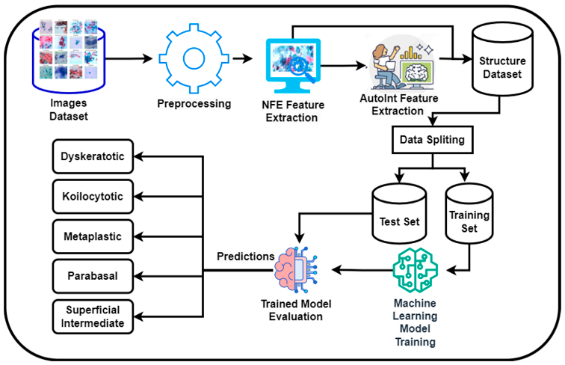

Figure 1. Feature Extraction Process

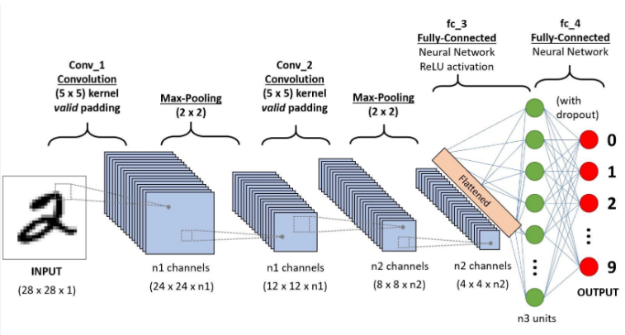

(a) Temperature field

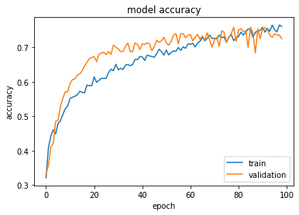
(b) Accuracy Levels

Figure 2. Three heat sources

- CONCLUSIONS AND FUTURE WORK

It is mandatory to have conclusions in your paper. This section should include the main conclusions of the research and a comprehensible explanation of their significance and relevance. The limitations of the work and future research directions may also be mentioned. Please do not make another abstract.

acknowledgment

Acknowledgement section is not numbered and presented after the conclusion. Use the singular heading even if you have many acknowledgments. Avoid expressions such as “One of us would like to thank ...” Instead, write “This work is supported by the National Science Foundation (Grant numbers: xxxx, yyyy).”

REFERENCES

- J. Shan and H. Ma, "Optimization of Network Intrusion Detection Model Based on Big Data Analysis," in Journal of Cyber Security and Mobility, vol. 13, no. 6, pp. 1357-1378, November 2024, doi: 10.13052/jcsm2245-1439.1366.
- K. Kostas, M. Just and M. A. Lones, "Individual Packet Features are a Risk to Model Generalization in ML-Based Intrusion Detection," in IEEE Networking Letters, vol. 7, no. 1, pp. 66-70, March 2025, doi: 10.1109/LNET.2025.3525901.
- G. Zachos, G. Mantas, K. Porfyrakis, J. Manuel Camões Sobral de Bastos and J. Rodriguez, "Anomaly-Based Intrusion Detection for IoMT Networks: Design, Implementation, Dataset Generation, and ML Algorithms Evaluation," in IEEE Access, vol. 13, pp. 41994-42028, 2025, doi: 10.1109/ACCESS.2025.3547572.
- N. Wei et al., "An Autoencoder-Based Hybrid Detection Model for Intrusion Detection With Small-Sample Problem," in IEEE Transactions on Network and Service Management, vol. 21, no. 2, pp. 2402-2412, April 2024, doi: 10.1109/TNSM.2023.3334028.
- H. Im and S. Lee, "TinyML-Based Intrusion Detection System for In-Vehicle Network Using Convolutional Neural Network on Embedded Devices," in IEEE Embedded Systems Letters, vol. 17, no. 2, pp. 67-70, April 2025, doi: 10.1109/LES.2024.3475470.
- Q. Shi, J. Liu, L. Wei, J. Jiao, B. Han and Z. Wu, "SegCoT: Dependable Intrusion Detection System Based on Segment-Wise CoTransformer for Ship Communication Networks," in IEEE Transactions on Network and Service Management, vol. 22, no. 5, pp. 5062-5073, Oct. 2025, doi: 10.1109/TNSM.2025.3580471.
- T. Ye et al., "Vision-Based Few-Shot Railway Intrusion Detection via Dual-Detector and Contrastive Learning," in IEEE Sensors Journal, vol. 25, no. 17, pp. 32899-32915, 1 Sept.1, 2025, doi: 10.1109/JSEN.2025.3592669.

